OSSP SKILL 1: -
Q) To Install Linux VM, Configure GCC, Setup Git Repository, Create Project Structure, Understand Shell Architecture, Build Initial Make file.

CODE: -
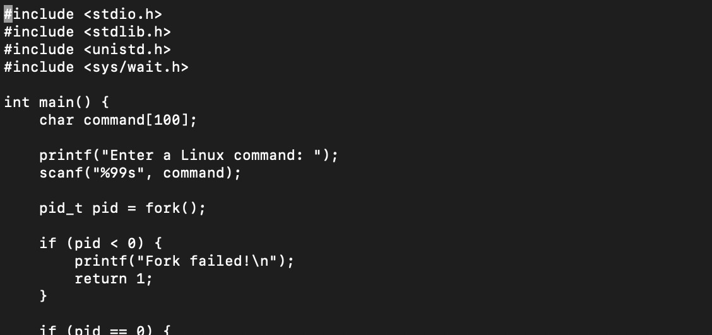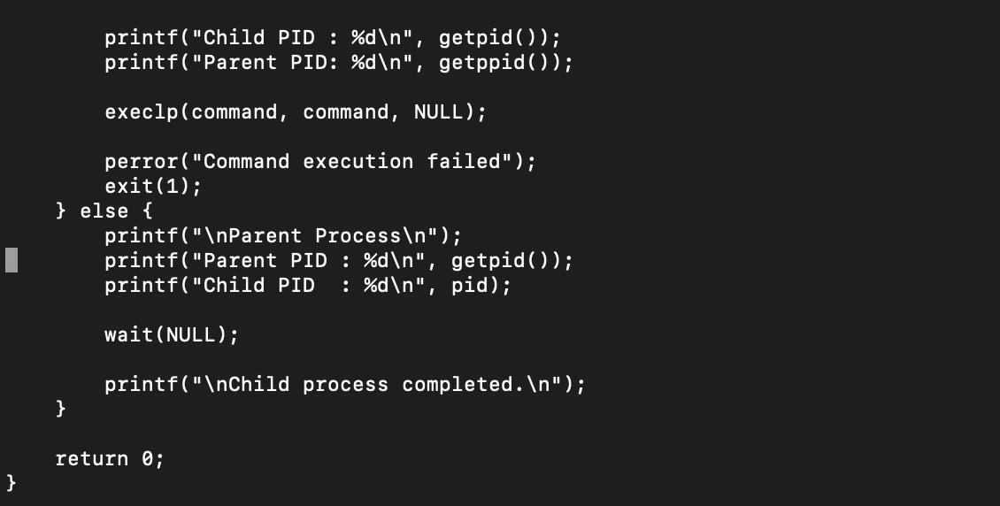

OUTPUT:

